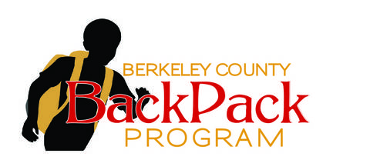
Sponsorship Form

Join our growing list of supporters! By becoming a friend of the BackPack Program, you will be giving back to the Berkeley County community and ensuring the future of its young students.
Company/Organization Name: _________________________________
Address: ___________________________________________________
City/State/Zip: ______________________________________________
Contact Person: _____________________________________________
Phone Number: _____________________________________________
Email Address: ______________________________________________
Level of Sponsorships Available
⃝ Level 1- Any Monetary Donation made through the website $0-$99
⃝ Level 2- Monetary Donation of $100+ Name on website
⃝ Level 3- Monetary Donation of $500+ Logo, number, website on website
⃝ Level 4- Monetary Donation of $1,000+ Same as 3 plus logo on brochures
⃝ Level 5- Monetary Donation of $2,000+ Same as 4 plus logo on banner
⃝ Level 6- Monetary Donation of $5,000+ Same as 5 plus logo on team shirts
⃝ Sponsor a child for $20.00 a month
Please make check payable to Berk Co BackPack Program and mail to PO Box 2153 Hedgesville, WV 25427 or by visiting our website at www.feedbcwvkids.org and clicking on the donate button. For sponsorship levels 3-7, please email your logo to berkcobpprogram@yahoo.com. Thank you for helping us end childhood hunger… one backpack at a time!

